**Lab Session #7**

**Visualization using python**

**Aim:** To visualize data and series using matplotlib and seaborn packages in python.

**Problem Definition**: Develop python programs for the following:

1. Implement Taylor Series for 5 terms and visualize the same using matplotlilb.
2. Download the Penguin dataset from <https://www.kaggle.com/code/parulpandey/penguin-dataset-the-new-iris/notebook> and plot the following visualizations:
   1. Scatter plot to study relationship between flipper length and bill length.
   2. Histogram plot for bill depth.
   3. Bar plot for the body mass of the penguin species by sex.
   4. Box plot for distribution of flipper length by species.
   5. Pair plot for pairwise visualization of the attributes.
3. Infer any 3 observations from each of the plot.

**Theory:** Seaborn is a Python library for data visualization built on Matplotlib. Matplotlib is used to plot 2D and 3D graphs, while Seaborn is used to plot statistical graphs. Because Seaborn builds on Matplotlib, you can use these two libraries together to create very powerful visualizations.

You can install the Seaborn with the following command: **pip install seaborn**

When you install the Anaconda, Seaborn is installed automatically. After installing Seaborn, we need to import this library to use it. Let’s import Seaborn: **import seaborn as sns**

With Seaborn, you can easily load some famous datasets used for data science.

1. Scatter Plot: The best technique for understanding data is the scatter plot. The scatter plot is used to display the relationship between variables.
2. Histogram: The second type of plot I’m going to show is histogram. Histogram shows the distribution of the data. You can use the histogram plot to see the distribution of one or more variables.
3. Bar Plot: A bar plot represents an estimate of the central tendency for a numeric variable with the height of each rectangle.
4. Box Plot: The box plot is used to compare the distribution of numerical data between levels of a categorical variable.
5. Violin Plot: You can think of the violin plot as a box plot. This plot is used to compare the distribution of numerical values ​​among categorical variables.
6. Facet Grid: You can use a facet grid to see a grid graph of the different subsets in your dataset. For example, let me draw the histogram plot of the penguins’ flipper length according to the island and sex variables. Let’s assign column and row variables to add more subplots to the figure.
7. Pair Plot: Seeing the pair relationship between the variables in the dataset is one of the important steps of data analysis. You can use the pairplot method to see the pair relations of the variables. This function creates cross-plots of each numeric variable in the dataset.
8. Heatmap: Finally, let’s look at the heatmap. Heatmap is one of a very useful visualization techniques. You can use this technique to see correlations between numerical variables.

Matplotlib is an amazing visualization library in Python for 2D plots of arrays. Matplotlib is a multi-platform data visualization library built on NumPy arrays and designed to work with the broader SciPy stack. It was introduced by John Hunter in the year 2002. One of the greatest benefits of visualization is that it allows us visual access to huge amounts of data in easily digestible visuals. Matplotlib consists of several plots like line, bar, scatter, histogram etc. Installation : Windows, Linux and macOS distributions have matplotlib and most of its dependencies as wheel packages.

**Codes:**

1] Implement Taylor Series for 5 terms and visualize the same using matplotlilb.

**Program:**

import numpy as np

import matplotlib.pyplot as plt

# Function to calculate the factorial of a number

def factorial(n):

if n == 0:

return 1

else:

return n * factorial(n - 1)

# Function to calculate the value of the Taylor Series at a given x

def taylor_series(x):

n_terms = 5 # Number of terms in the Taylor Series

result = 0

for n in range(n_terms):

term = (-1) ** n * x ** (2 * n) / factorial(2 * n)

result += term

return result

# Generate x values from -10 to 10

x_values = np.linspace(-10, 10, 100)

# Calculate y values using the Taylor Series expansion

y_values = np.array([taylor_series(x) for x in x_values])

# Plot the Taylor Series

plt.plot(x_values, y_values, label="Taylor Series (5 terms)")

plt.xlabel("x")

plt.ylabel("f(x)")

plt.title("Taylor Series Expansion")

plt.legend()

plt.grid(True)

plt.show()

**Output:**



**2]** plot the following visualizations:

**a)** Scatter plot to study relationship between flipper length and bill length.

**Code:**

import pandas as pd

import matplotlib.pyplot as plt

# Load the dataset

df = pd.read_csv('C:/Users/Downloads/archive/penguins_size.csv')

plt.scatter(df['culmen_length_mm'], df['flipper_length_mm'])

plt.xlabel('Culmen Length (mm)')

plt.ylabel('Flipper Length (mm)')

plt.title('Relationship between Flipper Length and Culmen Length')

plt.show()

**Output:**



**b)** Histogram plot for bill depth.

**Code:**

import pandas as pd

import matplotlib.pyplot as plt

# Load the dataset

df = pd.read_csv('C:/Users/Downloads/archive/penguins_size.csv')

plt.hist(df['culmen_length_mm'], bins=10)

plt.xlabel('Culmen Length (mm)')

plt.ylabel('Count')

plt.title('Histogram of Culmen Length')

plt.show()

**Output:**



**c)** Bar plot for the body mass of the penguin species by sex.

**Code:**

import pandas as pd

import matplotlib.pyplot as plt

import seaborn as sns

# Load the dataset

df = pd.read_csv('C:/Users/Downloads/archive/penguins_size.csv')

sns.barplot(data=df, x='sex', y='body_mass_g')

plt.xlabel('Sex')

plt.ylabel('Body Mass (g)')

plt.title('Body Mass of Penguin Species by Sex')

plt.show()

**Output:**

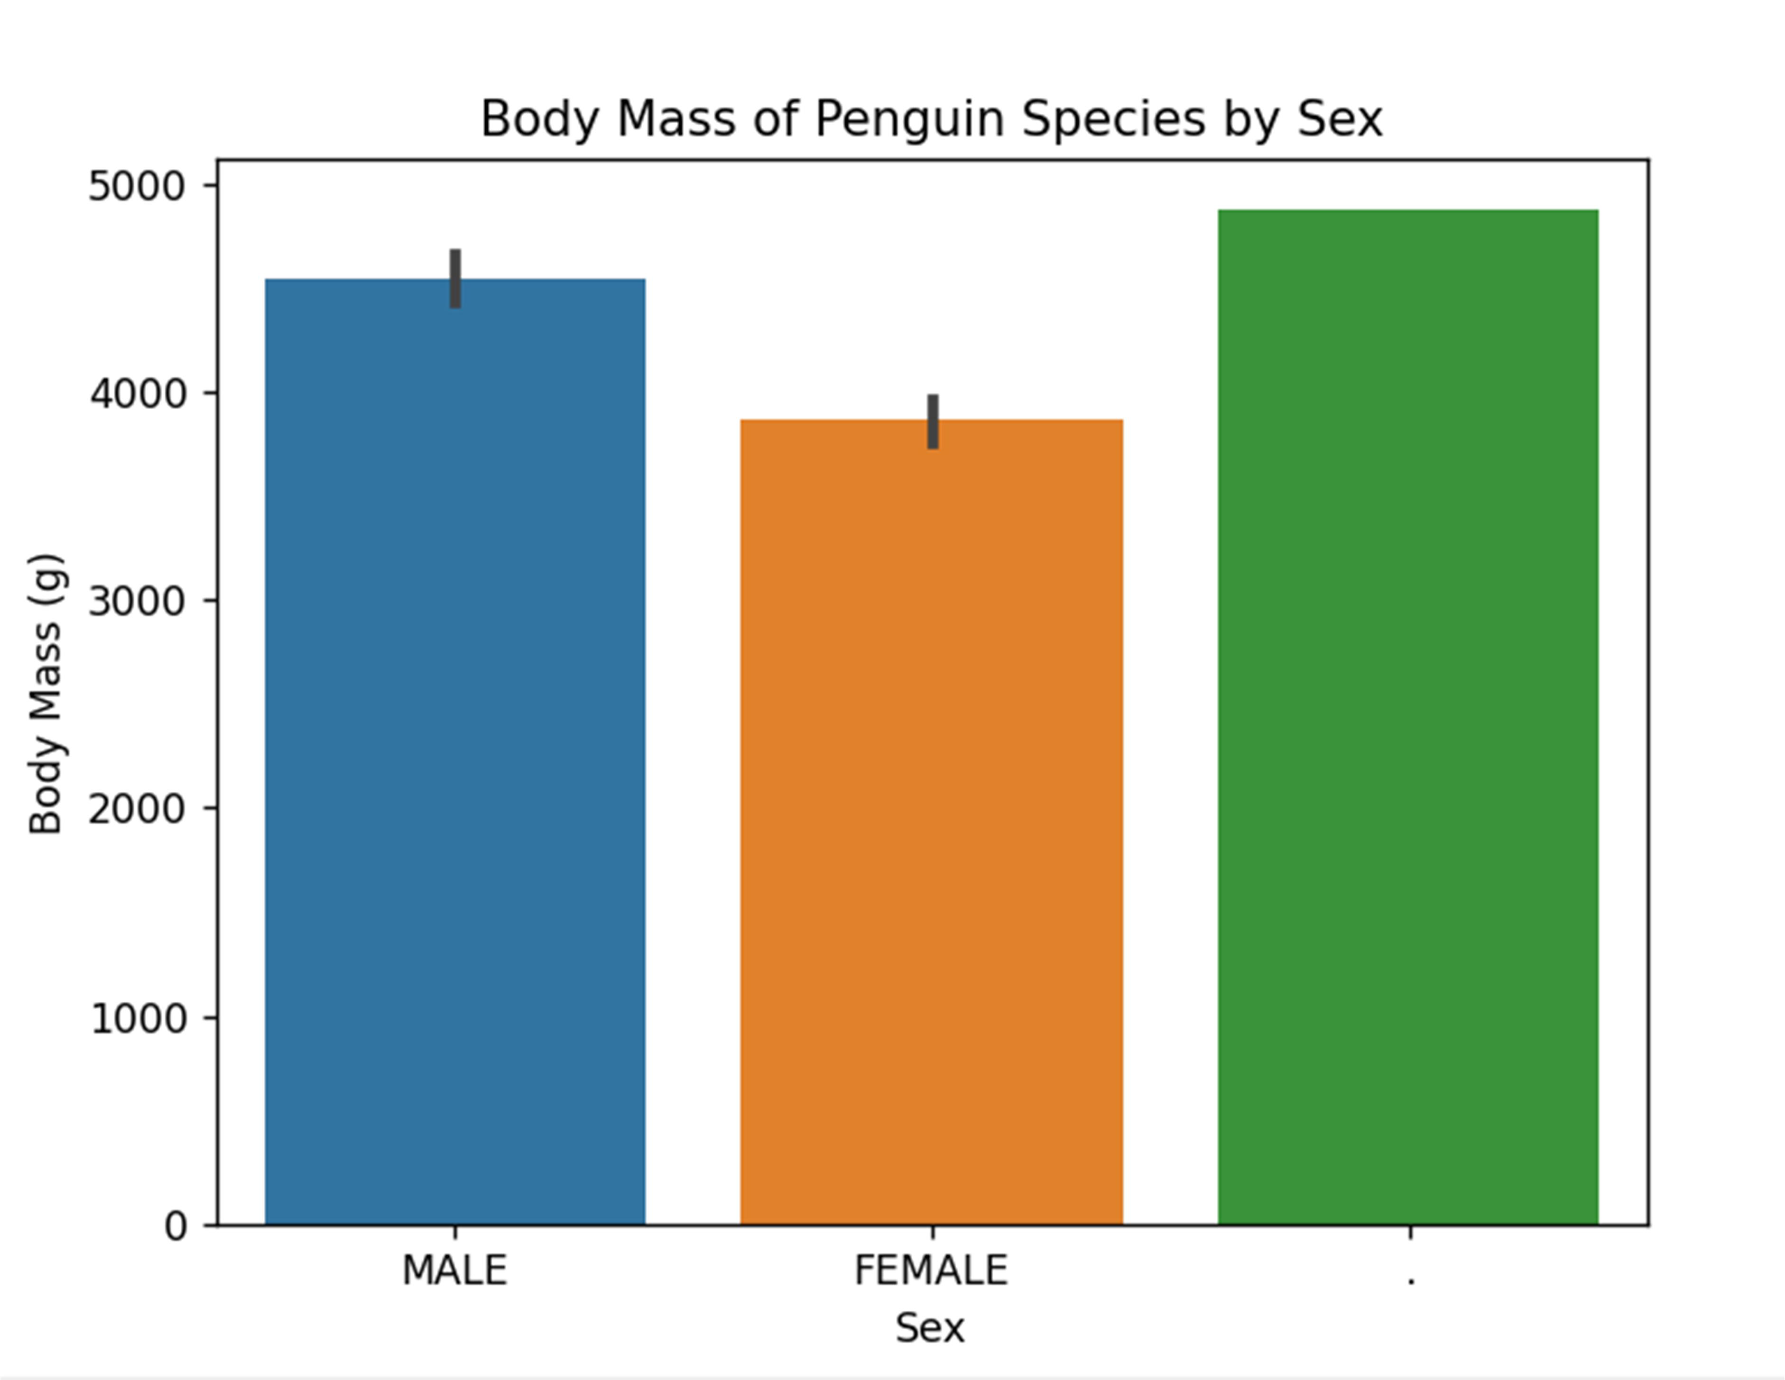

**d)** Box plot for distribution of flipper length by species.

**Code:**

import pandas as pd

import matplotlib.pyplot as plt

import seaborn as sns

# Load the dataset

df = pd.read_csv('C:/Users/Downloads/archive/penguins_size.csv')

sns.boxplot(data=df, x='species', y='flipper_length_mm')

plt.xlabel('Species')

plt.ylabel('Flipper Length (mm)')

plt.title('Distribution of Flipper Length by Species')

plt.show()

**Output:**



e) Pair plot for pairwise visualization of the attributes.

Code:

import pandas as pd

import seaborn as sns

import matplotlib.pyplot as plt

# Load the dataset

df = pd.read_csv('C:/Users/Downloads/archive/penguins_size.csv')

sns.pairplot(data=df, hue='species')

plt.title('Pairwise Visualization of Attributes')

plt.show()

**Output:**

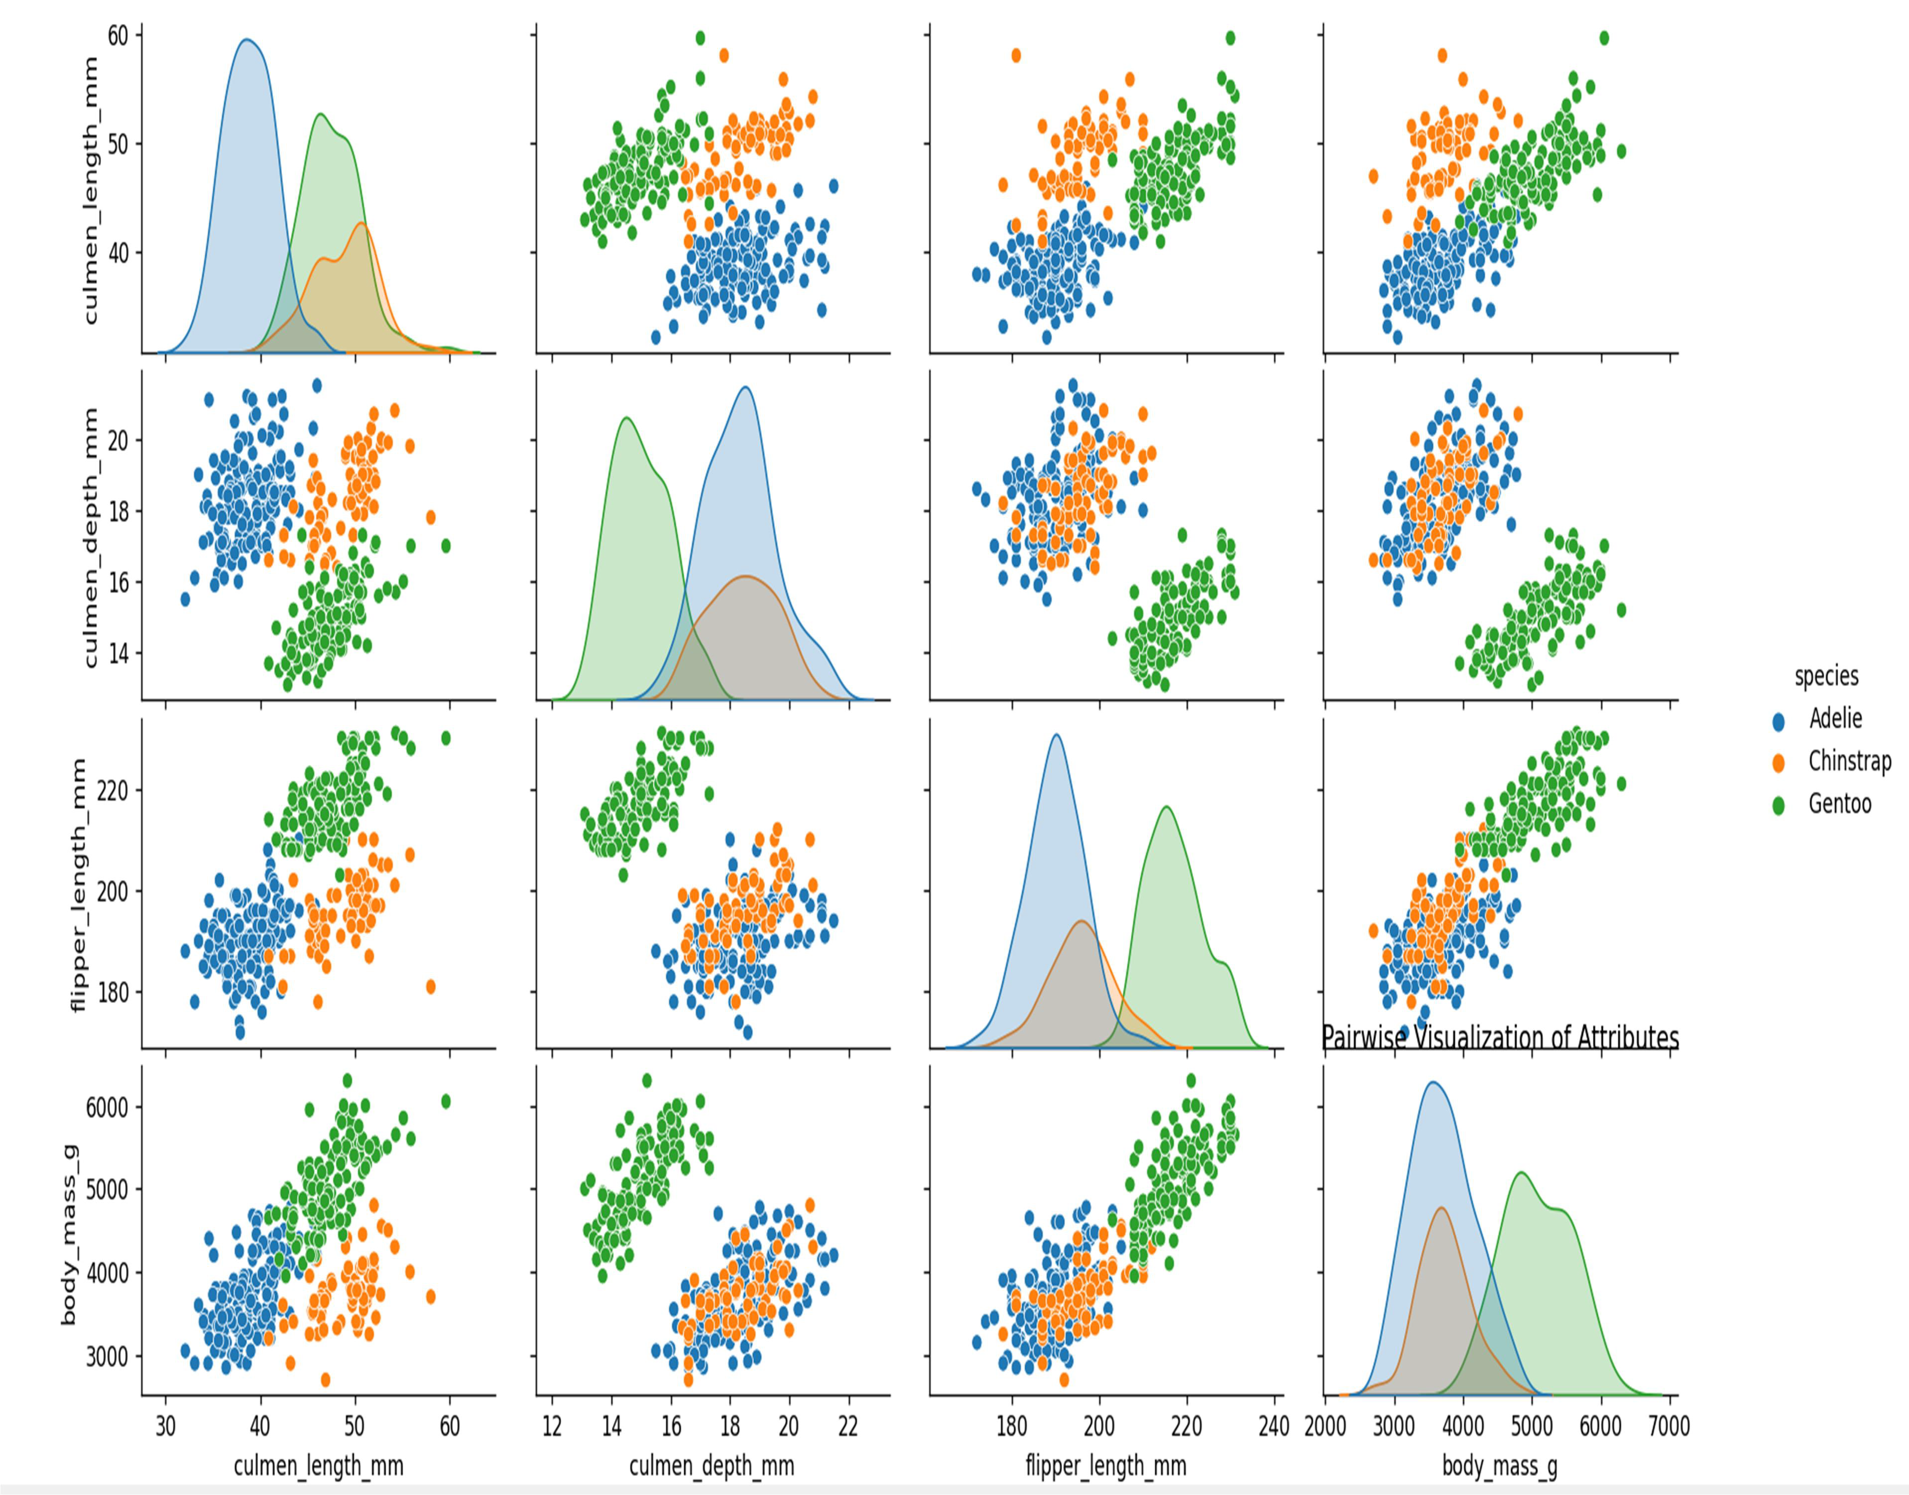

**3]** Infer any 3 observations from each of the plot.

Observations from Penguin Dataset Plots are

**1.** Scatter Plot: Flipper Length vs Bill Length

- There is a positive correlation between flipper length and bill length, indicating that

penguins with longer bills tend to have longer flippers.

- Clusters of data points suggest the presence of different penguin species with varying

flipper and bill lengths.

- The range of bill lengths is wider compared to flipper lengths, indicating greater variability

in bill size among the penguins.

**2.** Histogram Plot: Bill Depth

- The distribution of bill depths is approximately symmetric and bell-shaped.

- The majority of penguins have bill depths between 16 and 18 mm.

- Fewer penguins exhibit extreme bill depths, suggesting that most individuals fall within

the average range.

**3.** Bar Plot: Body Mass by Sex

- Male penguins tend to have slightly higher body mass compared to female penguins.

- There is significant overlap in body mass between males and females, indicating that

body mass alone may not reliably indicate sex.

- The difference in body mass between males and females is not substantial, suggesting

that sexual dimorphism in body size may not be prominent in this penguin population.

**4.** Box Plot: Flipper Length by Species

- Adelie penguins generally have the shortest flipper lengths among the three species.

- Gentoo penguins have the widest range of flipper lengths, indicating greater variation

within the species.

- Chinstrap penguins have a slightly higher median flipper length compared to Adelie

penguins, but their range is narrower than that of Gentoo penguins.

**5.** Pair Plot: Pairwise Visualization of Attributes

- There is a strong positive correlation between flipper length and body mass, indica􀆟ng

that larger penguins tend to have longer flippers.

- Different species exhibit distinct patterns in their attribute relationships, suggesting

species-specific characteristics.

- Sca􀆩er plots on the diagonal show attribute distributions, providing insights into their

ranges and variabilities within the dataset.

**Conclusion:**

The analysis of the Penguin dataset using various plots has revealed interesting observations

regarding the relationships and distributions of different attributes. These observations

contribute to our understanding of penguin physical characteristics and can be further

explored to gain deeper insights into the species' biology and behavior.

Please note that these observations are general interpretations and may vary depending on

the specific dataset and its characteristics.